Path planning for Mobile Robotics

Learning objectives
- Introduction to path planning
- Configuration Space - From both book
- Graph-based planning algorithms
  - Dijkstra’s algorithm
  - A*
- Sampling-based path planning
  - Rapidly Exploring Random Trees
- PRM (Probabilistic Roadmap) : a probabilistic algorithm for path planning
- Environment Modeling for Path planning : How to represent the environment in which the robot will move, including grid maps, topological maps, and geometric maps.
- Road map path planning (Introduction to Autonomous Mobile Robots, page 261)
  - Visibility graph
  - Voronoi graph
- Cell decomposition path planning (Introduction to Autonomous Mobile Robots, page 264)
  - Exact cell decomposition
  - Exact cell decomposition
- Potential field path planning (Introduction to Autonomous Mobile Robots, page 264)
  - Attractive Potential
  - Repulsive Potential
  - The Extended Potential Field Method
- Obstacle Avoidance (Brief description and why to use in path planning)
- Example: (write brief overview, not complex equations)
  - The Path Planning of Mobile Robot by Neural Networks and Hierarchical Reinforcement Learning ( https://www.frontiersin.org/articles/10.3389/fnbot.2020.00063/full )
Resources: http://lavalle.pl/planning/

Introduction to path planning
Mobile robots and robotic manipulators are increasingly being employed in many automated environments. These robots can be found in various applications such as service robots, autonomous mobile vehicles or even space exploration robots. These vehicles' navigation systems involve perception of their surroundings, localization, map building, motion control and path planning. Path planning is a key aspect for enhancing robot autonomy, its goal is to create a safe, optimal and collision free path in a static or dynamic, obstacle prone environment. The path is selected according to some guidelines, depending on the applications, some examples are shortest path, safety, minimum energy consumption and more. Nevertheless, path planning is a non-deterministic polynomial time (NP) hard problem, where the complexity increases as the degrees of freedom increase.
Path planning can be divided into global path planning and local path planning:
Global path planning - Global path planning assumes that the robot has complete knowledge about the environment. In other words, the path is completely planned before the robots begin to move. The accuracy of the planned path is completely dependent on the accuracy of the environmental information. The robot in global path planning is map-based and commonly works off-lime. The response time is also slower because of the generation of environmental models, these models often take a lot of storage space and can generate more interference signals.
Local path planning - the environmental information in local path planning is unknown or partially known. Therefore, the robot depends on external information collected by its sensors to navigate. These types of robots work online and generally have a fast response.
Configuration space
The configuration space is a transformation from the physical space to another space in which the robot is treated as a point. The robot is represented as the controllable degrees of freedom (e.g. x and y coordinates). This configuration can be done by reducing the robot to a point-mass and growing all obstacles by the length of the longest extension of the robot from its center.
Configuration - vector containing the parameters required for defining the position state of vehicle
Configuration space or C-space - all possible set of configurations of the vehicle
Additional resources: 2D robotic manipulator visualization

Graph based path Planning

Introduction to graphs
A graph is a data structure that consists of a finite set of vertices called nodes, and a finite set of ordered pairs of the form ( u, v ) called edges. Graphs are very important in real-life applications, as they can represent networks. These networks include paths in a city, social or circuit network. In robotics this data structure can be used to represent relationships between objects ( e.g. distances in terms of edges between robots). These connections help communicate information between robots. The edges can be directed or undirected, meaning they can have a specific direction or be bidirectional. For example, in a map of a city the edges can be the roads, where some can be one-way streets or not.

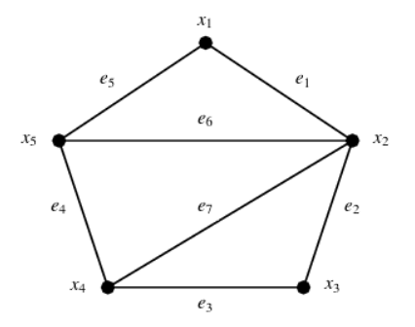

Figure Graph G = ( X, E ) : An example of an undirected graph of 5 vertices.
If two nodes are connected by an edge, they are called adjacent or neighbors, otherwise they are called disjoint. Using the figure above, vertices x₁ and x₂ are adjacent to each other through the edge e₁. Given a vertex x, the number of edges adjacent to it are called degrees (e.g. d (x₁ ) = 2 ). Sometimes, the set of vertices of a graph G can be denoted as V (G) and the set of edges is E (G). In practical applications, graphs can be small with 5 or 10 vertices, but they can also be hundreds and thousands of vertices and edges. There are several ways to store this information in computer memory, the most common representations are as follows:

Adjacency lists - Consider graph G from the previous figure. For every vertex x, you can form a list of all its neighbors. This set is called an adjacency list
- x₁ = x₂ , x₅
- x₂ = x₁ , x₃ , x₅
- x₃ = x₂ , x₄
- x₄ = x₃ , x₅
- x₅ = x₁ , x₂ , x₄
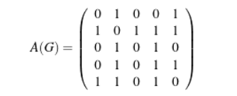
Adjacency matrix - And adjacency matrix is a 2D array ( table) that has one row and one column for each vertex. If vertex x_{i} is adjacent to vertex x_{j} , then ( i, j ) in the matrix will be 1, otherwise is 0.

Figure: Adjacency matrix of the graph G

Additional resources: Introduction to Graph Theory by Vitaly I. Voloshin

Graph-based planning algorithms
Graphs are used for many real-life problems, one of them is the “shortest” path problem. In the context of robotics, the nodes represent robots or locations, and the edges represent the distances between them.

Dijkstra’s algorithm
One of the earliest and simplest algorithms for path planning is Dijsktra’s algorithm, created by Dr Edsger W Dijsktra, computer scientist and software engineer in 1994. In summary, the algorithm is an iterative process that begins in the starting vertex by marking all its direct neighbors with the cost to reach them. The algorithm inspects the neighboring vertex with the lowest cost and all its adjacent vertices, marking them with the cost to research them via the current node in consideration. Once all adjacent vertices have been checked, the algorithm continues to the vertex with the lowest cost. When the algorithm reaches the goal and there exists no other vertex with a lower cost to the goal, it terminates and the robot can follow the edges with the lowest edge weight towards the goal. There are some limitations to this algorithm, as it can only work with a positive weighted graph, because the weight of the edges have to be added to find the shortest path. If there exists a negative edge in the graph, when the weights are added, it will subtract from the total, making the algorithm not work properly. However, this should not be a problem for distances, as distances can never be zero or negative.
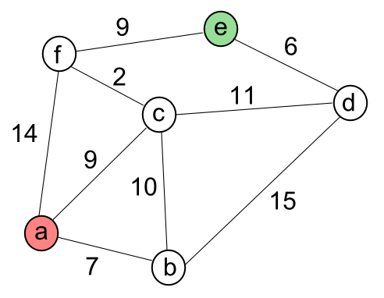

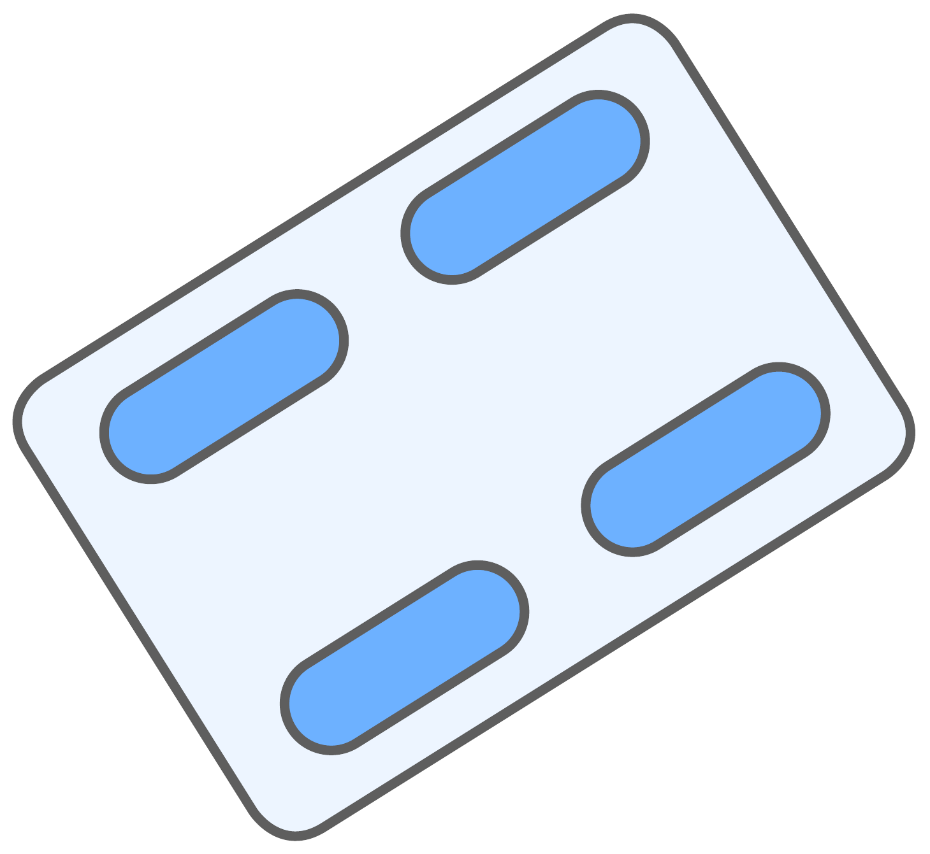

Figure: Undirected graph where the edge weights represent distances.
Suppose we have a mobile robot that needs to travel from vertex a to vertex e. Let's make a list of the unvisited nodes and their distances. The distance from the robot to the source node is 0 and the distance from the source node to all other nodes is yet to be determined, therefore they can be assigned a distance of infinity ( denoted as inf ).
Unvisited nodes = { b, c, d, e, f }
Visited = {a}

node | distance
a | 0
b | inf
c | inf
d | inf
e | inf
f | inf

Now we begin to mark the cost to the adjacent nodes of a. The distance to a remains the same but now nodes b, c and f will have updated. The rest of the nodes stay with the same cost as we do not have access to any of them. From the adjacent nodes we choose the one with the lowest cost. We place node b in the visited set because it has the lowest cost.

node | distance
a | 0
b | 7
c | 9
d | inf
e | inf
f | 14

Now we have node a and b, considering these nodes, we can update the costs accordingly. The only change in cost is the cost to node d (7 +15 = 22 ). Now we can examine the neighboring nodes and inspect the unvisited node with the lowest cost, which in this case is node c.
Unvisited nodes = { c, d, e, f }
Visited = {a, b}

node | distance
a | 0
b | 7
c | 9
d | 22
e | inf
f | 14

Now we have nodes a, b, and c to consider when updating the costs. Having node c, we have a second path to node f that costs less. The path now costs 11 ( 9 + 2 = 11). The cost to node d also gets updated to 20 ( the previous path to d was from a to b with a cost of 22. However, now we have c, which has access to node d with a cost of 20 because 9 + 11 = 20 ). The cost of node e remains as inf because none of our current visited nodes has direct access to it. Out of the adjacent unvisited node we choose the one with the lowest cost, in this case is node f.
Unvisited nodes = { d, e, f }
Visited = {a, b, c}

node | distance
a | 0
b | 7
c | 9
d | 20
e | inf
f | 11

Unvisited nodes = { d, e }
Visited = {a, b, c, f }
Now we count with nodes a, b, c, and f. Now we have access to node e, the cost is updated to 20 ( 11+ 9 = 11). The cost to d remains the same. Now we take the unvisited node with the lowest cost, in this case node d.

node | distance
a | 0
b | 7
c | 9
d | 20
e | 20
f | 11

Unvisited nodes = { e }
Visited = {a, b, c, f, d}
Only the goal node remains. There is no change in cost as the lowest cost to e remains as 20. We have finished the algorithm and now we can plan the path to e from a.

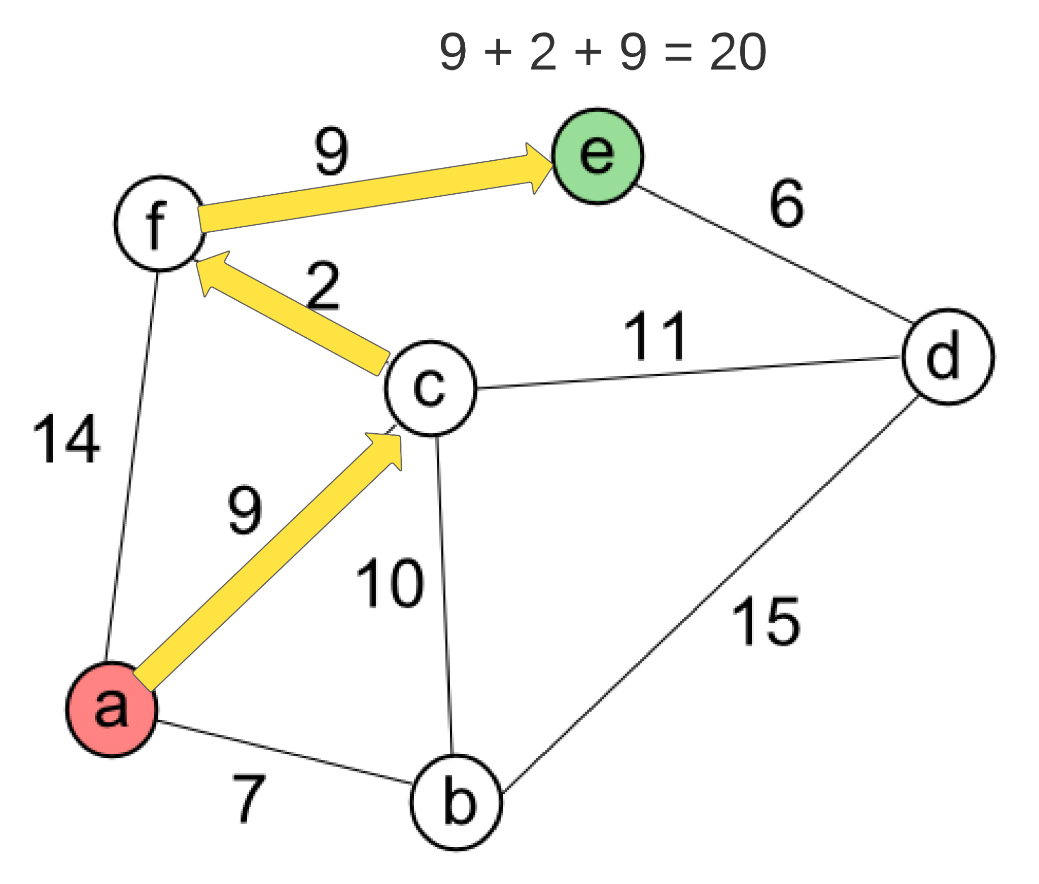

A* algorithm
The A* algorithm is a well-known path planning algorithm, the main difference is that this algorithm has “brains”, instead of exploring in all directions, it uses knowledge of an approximate erection to reach the goal. It uses heuristics to search for the shortest path in a graph or maze; heuristic is nothing more than a smart guess. The algorithm is guided to find an optimal path by an acceptable heuristic function h(n), this means that it will never overestimate the actual cost. For example, we could give priority to nodes that have a lower estimated distance to the goal. This can be done by marking each node with the actual distance and the estimated distances to the target by calculating the Euclidean or Manhattan distance.
This algorithm uses the evaluation function f(n) = g(n) + h(n) where
g(n) = cost so far to reach n
h(n) = estimated cost from n to target
f(n) = estimated total cost of the path through n to target

These are two common approximation heuristics to estimate the distance;
Manhattan distance - This heuristic is used when the object is allowed to move in only 4 directions ( right, left, top, bottom ). It is the sum of absolute values of differences in the goal’s x and y coordinates and the current cells x and y coordinates respectively.
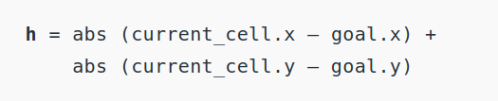

Euclidean distance - This is used when the object can move in any direction. It is the distance between the current cell and the goal cell using the formula
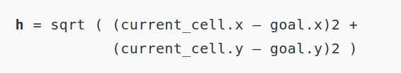

For a visual representation on how the A* algorithm works visit: A* search on Brilliant.org

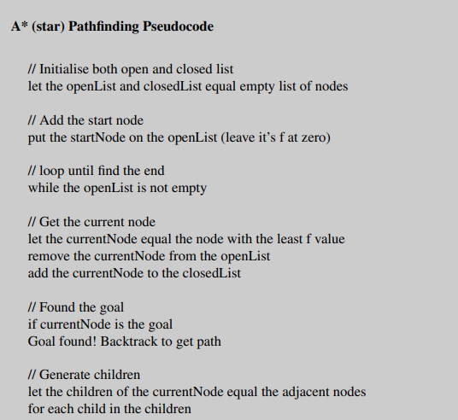

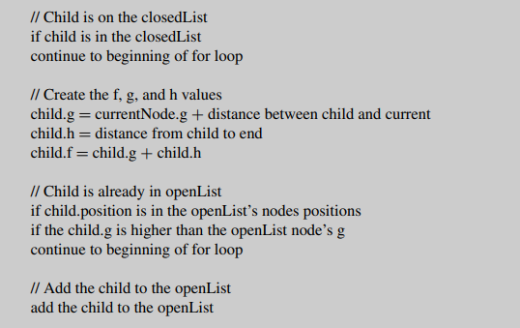

Both algorithms are extensively used even to this day for digital mapping services, social network applications and Robotic path planning. The A* algorithm was part of the Shakey Project. Shakey was a robot made to navigate spaces that used A* algorithm for finding least-cost paths.

Sampling based path planning
The previously mentioned algorithms are complete algorithms, meaning that they are guaranteed to find a solution if one exists, however these algorithms don't perform well in practice as there can be limitations like lack of available memory or time. Sampling-based motion planning is a technique that is both fast and efficient since it does not require fully exploring the configuration space of the problem. This strategy involves randomly sampling the configuration, checking for validity and then adding it to a tree or graph structure that can be queried for a solution. An example of a sampling based planner is the Rapidly-exploring Random Trees (RRT).

Rapidly-exploring Random Trees
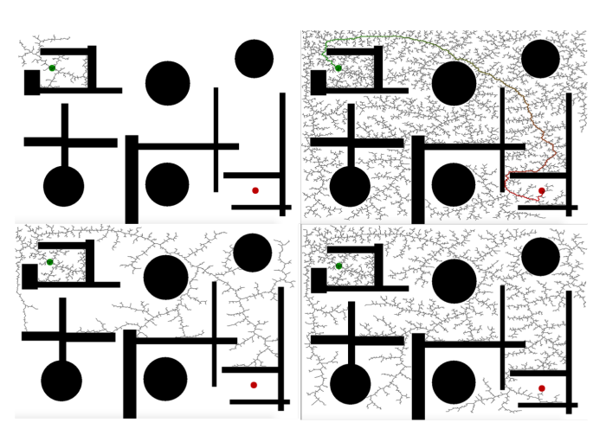
An RRT grows a single tree form the robot’s starting point until one of its branches reaches the target point, this technique covers a large area rapidly. In essence, the RRT consists of a set of points or nodes in a space connected by straight line edges. For the tree to grow, a point is placed in a random spot of the map, next step is figuring out which existing node is the closest, then a straight line is drawn between the random point and the closet node ( by choosing random points the tree can grow and explore different directions of the space).

The following pseudo-code represents an RRT planner:
Let G $⊂$ X be a d-dimensional sphere in the state space considered to be the goal.
max_dist the longest permissible edge length
t the allowed time
k the maximum number of vertices to allow in the tree
goal_bias the percentage of the time the algorithm should try to connect to goal state
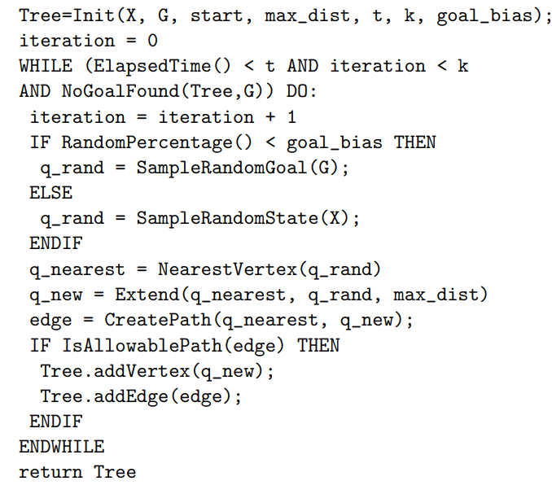

Following this method does not guarantee the shortest path, for this an alternative has been created, the RRT*, it always minimizes the overall path from the root to every vertex. To do this, only points in the tree within a d-dimensional sphere of fixed radius from q_rand are considered. Next, vertices near q_rand are evaluated to inspect if an edge between them and q_rand would be shorter than the current edge. On the other hand, since this strategy randomly samples from discrete and arbitrary maps, the paths can be irregular and jagged. This problem can be improved with path smoothing, by connecting points of the path using splines, polynomial curves or trajectory snippets. RRTs are still widely used for motion planning, specifically in robotic path planning for autonomous mobile vehicles, swarm robotics and collision avoidance for robotic manipulators.
Additional resources: RRT visualization in a 3D map

Probabilistic RoadMaps (PRM)
Similar to Rapidly-exploring Random Tree (RRT), Probabilistic RoadMaps (PRM) is an algorithm that builds a graph to perform motion planning. The basic idea behind PRM is to take random samples from the configuration space, examine if they are not collisions with obstacles, and use a local planner to map these configurations to other configurations close by. PRM consists of two phases: a learning phase and a query phase.
Learning phase - it's a graph called a roadmap, the nodes in this map are collision-free configurations and the edges are collision-free paths. They are built by picking a random configuration of the robot, if the configuration collides with an obstacle it will repeatedly keep picking random configurations until it is collision free. Once a collision-free configuration is found, by using a local path planner, connect the former configuration to the map.
Query phase - this step is essentially finding a path between an initial configuration and the goal. This is done by connecting the configurations to the roadmap and searching for local paths linking these nodes.
Local planner - is also important as it affects the outcome. It is imperative to be able to connect from any start and goal configurations of the roadmap or detect if that connection is possible in a timely manner. Thus, it seems preferable to use a fast local path planner to build large roadmaps with widely distributed configurations in the C-space. However there are a few tradeoffs, tast planners are less accurate, thus more nodes need to be generated and called more often. On the other hand, powerful planners can find paths between relatively isolated nodes but are slow.

Step 1 - Learning the map
- Roadmap is a graph G(V,E)
- The robot configuration q $→$ Q_free is a vertex
- Edge (q1, q2) implies collision-free path between these robots configurations
Initially, graph G is empty. A configuration q is randomly chosen and if q $→$ Q_free, then add to G; repeat until N vertices are chosen. For each q, select k closest neighbors and use the local planner to connect q to neighbor q’. If the connection is successful, add edge (q, q’). Here is the roadmap construction algorithm for the learning phase:

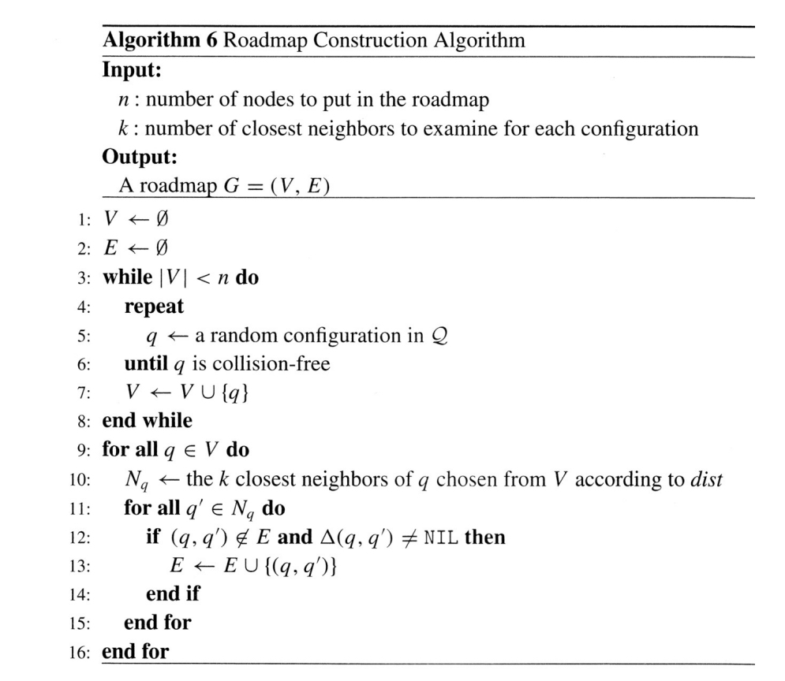

Step 2 - Finding a path
Given that q_init and q_goal need to connect each to the roadmap. We must find the nearest k neighbors of q_init and q_goal in the roadmap so we can plan a local path. However, the roadmap graph may have disconnected components. We need to find connections from q_init and q_gial to the same component. Once on the roadmap, use the shortest path algorithm.
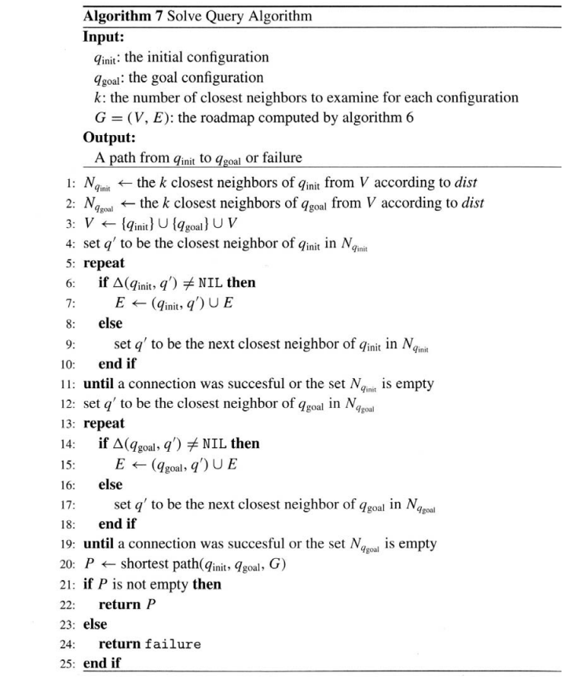

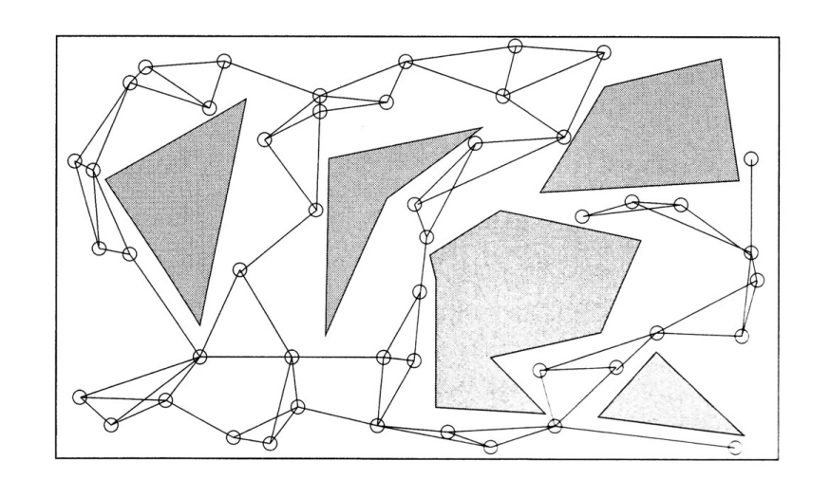
The following figures represent the steps detailed previously: learning phase (Figure 1) and query phase (Figure 2).

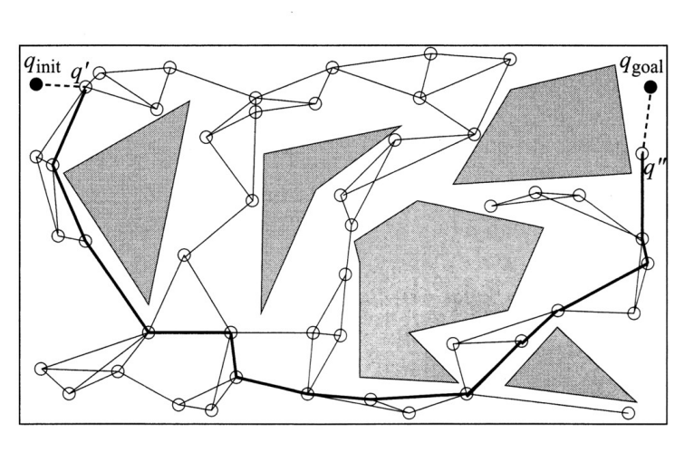
Figure 1: An example of a roadmap for a point robot in a two-dimensional Euclidean space. The gray shapes are obstacles, the empty circles are the nodes and the lines are the edges/paths.

Figure 2: An example of how to solve a query for the roadmap in Figure 1. The configurations q_init and q_goal are first connected to the roadmap through q’ and q’’. Then a graph search algorithm returns the shortest path denoted by the bold lines.

Environment Modeling for Path Planning
Robots need to do a number of tasks like manipulating objects, reacting to dynamic events, interacting with objects or other entities or traveling in dangerous or unknown terrain. In order to do so, robots use a representation or map of the complex environment they are navigating. These robots are given or have to implicitly build the space they will navigate. There are numerous map representations:

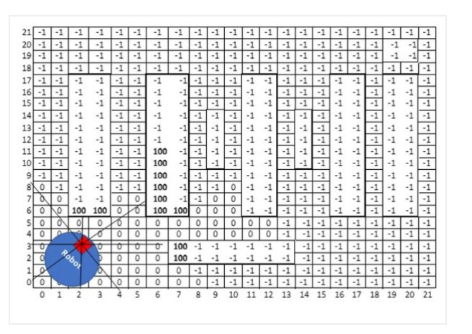
Occupancy grid maps - this map is saved as discrete approximations with chunks of equal size. Each cell can either have a binary or probabilistic value of being occupied or empty. The grid structure is a rigid non-parametric model that doesn't rely on feature detectors or sensors. Nonetheless, these types of maps require substantial memory resources. These mapping techniques can be used for factories, indoor facilities or underground mines, caves and hard to reach environments. The robots that often use this technique of mapping are indoor delivery robots and cleaning robots.

Figure: An occupancy graph representation of a factory floor. The robot is in blue and the red square is the LIDAR.

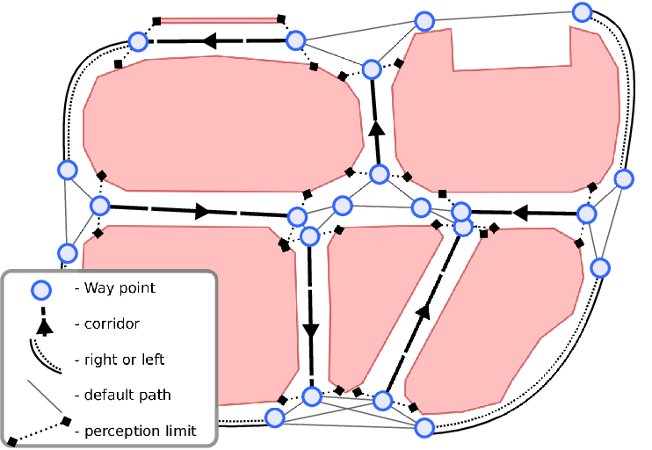
Topological maps - this mapping technique that involves abstracting a continuous spatial environment into a discrete sequence of topological events. A topological map is a human-like representation of an environment. This similarity benefits human-robot interaction, as it provides natural interfaces for commanding the robot and describing the environment. The primary purpose of these maps is to have these robots move reliably from one location to another, instead of producing a metrically accurate map. These maps are graph representations of the environment which stores places (vertices) and their correlation (edges); where the edges can represent the motor action needed to get from one node to another, direction, distance, path convenience, etc. These maps use space data storage and recognition only requires consistency, not accuracy.

Figure: Example of a topological map
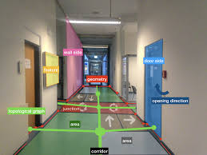
Geometric maps - geometric mapping in robotics refers to the process of creating a representation of the surrounding environment in the form of a geometric model. This model is typically generated using sensor data, such as laser range finders or depth cameras, to capture the shape and spatial layout of objects in the robot's vicinity. In the figure below you can see the geometrical features in red.

Roadmap Path Planning
Roadmap approaches in robotics involve constructing a network of 1D curves or lines called roadmaps in order to capture the connectivity of the robots free space, These road maps serve as a representation of the robots environment and are used for motion and path planning. The construction of a road map involves decomposing the robots configuration space baked on obstacle geometry. The aim is to create a set of roads that allow the robot to navigate through its free space efficiently while minimizing the total number of roads required. Two common road map approaches are the visibility graph and voronoi diagram.

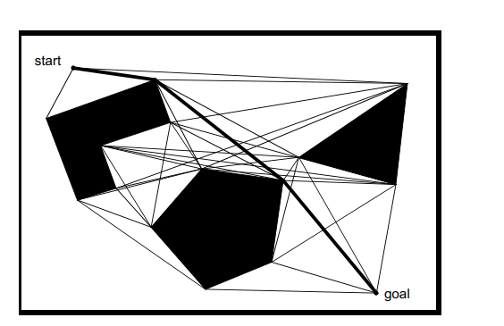
Visibility graph - its a polygonal configuration space consisting of edges joining all pairs of vertices that can see each other. The task for the path planner in this case is to find the shortest path from the initial position to the target position along the roads generated by the graph.The technique is used in mobile robotics because of its simple implementation. However, the solutions generated by this method tend to take the robot as close as possible to the obstacles, this ensures that the path is optimal in terms of length by sacrificing all sense of safety. A way to move around this caveat is to grow the obstacles by the radius of the robot.

Figure: Example of a visibility graph with a path from the starting point to the goal. You can see the proximity of the path to the obstacles.

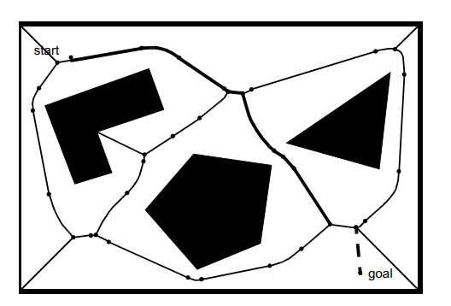
Voronoi diagram - the voronoi diagram is a complete roadmap that tends to maximize the distance between the robot and the obstacles. This diagram consists of the edges formed by these sharp ridge points. The paths in the voronoi diagram are far from optimal in terms of length; the maximization of the distance between the robot and the obstacle also presents a problem for robots with short range sensors. Nonetheless, this has a subtle advantage from the obstacle avoidance standpoint; executability. These diagrams are also useful in other applications such as multi-robot coordination, Voronoi diagrams can aid in coordinating the paths of multiple robots operating in the same environment. By constructing a Voronoi diagram based on the positions of the robots, individual Voronoi regions can be assigned to each robot, enabling them to navigate and explore the environment efficiently while maintaining separation.They can also be employed in path smoothing, after generating a path using other algorithms, Voronoi diagrams can be used to smooth the path by approximating it with a sequence of line segments connecting the Voronoi vertices. This helps in eliminating sharp turns and improving the overall trajectory.

Figure: Example of a Voronoi diagram with a path from the starting point to the goal. You can see the proximity of the path to the obstacles.

Cell Decomposition Path Planning
Cell decomposition involves the discrimination between geometric areas or cells that are free and areas that are occupied. In other words, the path between the initial configuration and the goal can be determined by dividing the C-space of the robot's configuration into small regions called cells. The algorithm can be summarized as follows:

Divide F into connected regions called “cells”
Compute a path within the cells, like passing through the cell boundaries.
Find the cell that has the initial and the goal, and search for a path in the connectivity graph to join them
Determine which open cells are adjacent and construct a connectivity graph

There exist two types of cell decomposition:
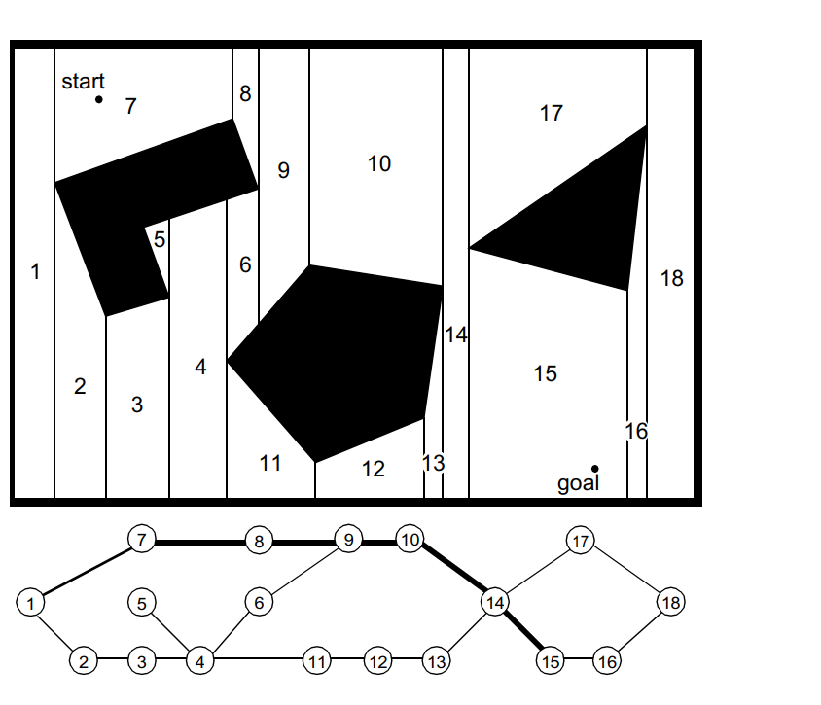
Exact cell decomposition - this cell decomposition happens when the boundaries between cells are placed as a function of the structure of the environment. The cells are either completely free or occupied, making the path planning network complete. This enables the robot to travel through cells and adjacent cells that are completely free. This representation can be efficient in a large and sparse environment. However, the key disadvantage is the number of cells . The path planning computational efficiency depends on the amount and complexity of the obstacles in the environment. You can see an example in the figure below.
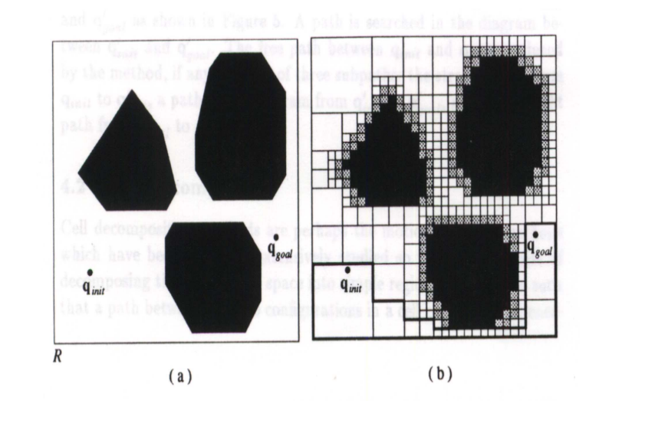
Approximate cell decomposition - Its decomposition results in an approximation of the map. Unlike exact cell decomposition, which is rarely used in mobile robotics because of its complexity to implement, approximate cell decomposition is one of the most popular techniques for path planning in mobile robotics because of its grid-based environmental representation. One common representation is fixed-size cell decomposition. An example is using the grassfire algorithm, unique for finding routes in fixed-size cell arrays, where it marks each cell with the distance to the goal cell until it reaches the initial cell. Here, the path planner estimates the robots distanced to the goal position and can recover a path solution by linking together the adjacent cells that are closer to the goal. This approach uses a recursive method to subdivide the cells until each cell lies either completely in free space or completely in the obstacle or, an arbitrary limit is reached.

Figure: In figure (a) we have the space. In figure (b) the space is decomposed and a path is calculated to the goal.

Potential Fields Path Planning
The basic idea behind potential field path planning creates a gradient across the robot's maps that directs the robot towards the goal. In potential fields, the robot is a point under the influence of an artificial potential field, which guides the robot to the goal while avoiding the obstacles. This is because the goal has attractive potential and repulsive potential.

Attractive potential - In artificial potential fields, the target point emits attractive energy, therefore, the robot is attracted and directed towards the goal. This can be represented as a parabolic function:
U_{att} (q) = $\frac{1}{2}$k_{att} $⋅$ $ρ$²_{goal} (q)
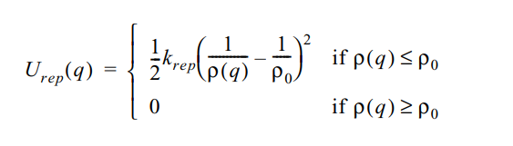
Repulsive potential - The idea is to generate a force that repels the robot from all known obstacles. The potential energy should be strong so when the robot gets near the object it reppels it but does not influence the path when the robot isn't in close proximity to the object.

With this in mind, the potential field acting on the robot can be computed as the sum the attractive field of the goal and the repulsive fields of the obstacles in the map, this can be seen as follows:
U(q) = U_{att}(q) + U_{rep}(q)
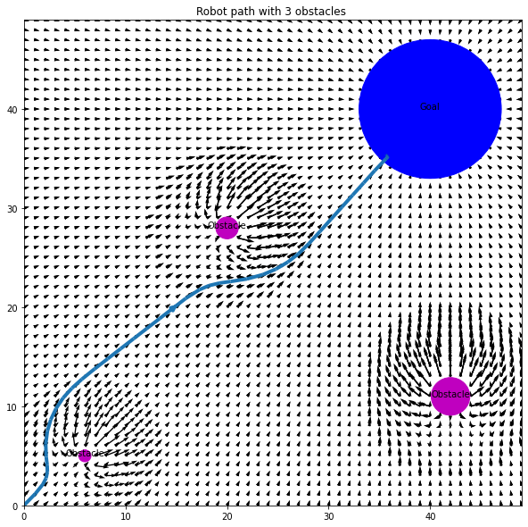

Figure: Example of a path planned using potential fields. The pink circles are the obstacles and the blue circle is the goal.
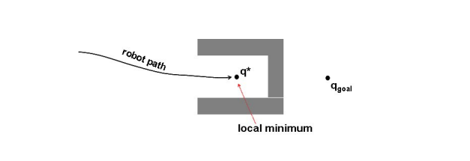
There exists some limitations to this approach that have been researched extensively. One of those disadvantages are the existence of local minima, this can cause the robot to be stuck in a false sense of completion as these local minima can appear to be the goal. Another problem is if the objects concave.

Figure: In this figure we can see an example of limitations of concave obstacles and local minima. The robot can get stuck in the local minima in the concave obstacles and not be able to get to the global minimum.

Extended Potential Fields Method
Similar to potential fields, an extended potential field approach was proposed. This method makes use of the attractive and repulsive forces with two additions: the rotational potential field and the taks potential field.
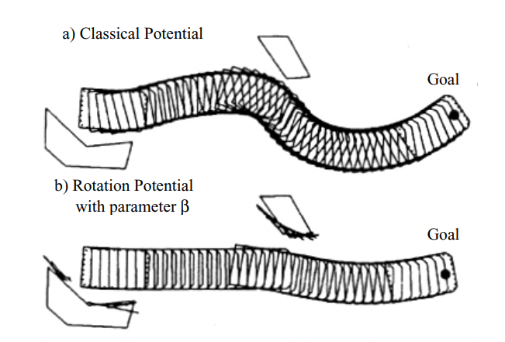
Rotation potential field - this assumes that the repulsive potential force is a function of the distance from the obstacle and the orientation of the robot. This can be done because of a gain factor that reduces the repulsive force when an object is parallel to the robot's direction of travel, since the object does not pose a threat to the robot's route, it enhances wall following.

Figure: Comparison between the original potential field method and the extended potential field.

Task potential field - in this approach, the robot's velocity is considered. From that, it filters out the obstacles that do not pose a threat in the near-term potential. A scaling is made for all the obstacles in front of the robot (this space is named sector Z).

Potential fields are popular among mobile roboticists because of their intuitive and simple implementation. This method has many variations, these variations include improvements to combat local minima using filling methods and random walks. On the other hand, improvements for oscillations in narrow passages like doorways or hallways.

Obstacle avoidance
Obstacle avoidance is a discipline in robotics whose key objective is the moving of vehicles on the basis of sensor information. This is especially useful for path planning in dynamic and unpredictable environments. Many confuse obstacle avoidance with path planning, but they are both different. Path planning is done before the robot is moving, while obstacle avoidance is done as the robot is in movement. Obstacle avoidance is a fundamental requirement in path planning for mobile robots. For example, a robot can avoid an obstacle by measuring the time it takes light articles or a burst of sound to hit an obstacle and return to the sensor. These returning photons or sound waves form images when processed by the program then the robot steers away from the object. The primary goal is to find an efficient path from a starting point to a destination, while avoiding any obstacles that might be present in the environment. Here are some of the key methods used for obstacle avoidance in path planning:
Potential Field Method: In the context of path planning, the potential field method creates a 'field' around obstacles. The field represents the potential risk of collision, with the risk increasing as the robot gets closer to the obstacle. The robot is then programmed to move in a direction that reduces its potential energy, effectively guiding it away from obstacles and towards the goal. This method is relatively simple to implement and can handle dynamic environments, but it can sometimes lead to local minima where the robot gets stuck in a position.
Vector Field Histogram (VFH): The VFH method constructs a histogram grid that represents the density of obstacles in the robot's environment. Each cell in the grid corresponds to a region in the environment, and the value in each cell represents the presence of an obstacle. The robot then uses this histogram grid to determine a safe direction to move in. This method is efficient and can handle dynamic environments, but it may not always find the shortest path.
Rapidly-exploring Random Trees (RRT): The RRT method is a probabilistic approach to path planning. It starts by constructing a tree with the robot's initial position as the root. The tree is then incrementally expanded towards randomly selected points in the environment. If the selected point is free of obstacles, a new node is added to the tree. The process continues until the tree reaches the goal or a predefined limit is exceeded. This method is effective in complex environments and can handle high-dimensional spaces, but it doesn't guarantee the shortest path.
Artificial Intelligence (AI) Techniques: AI techniques such as reinforcement learning and neural networks are increasingly being used in path planning. In reinforcement learning, the robot learns an optimal policy by interacting with the environment and receiving feedback in the form of rewards or penalties. Neural networks, on the other hand, can be used to approximate the value function in reinforcement learning, allowing the robot to handle large state spaces. For example, in the Deep Q-Learning Network (DQN) algorithm, a neural network is used to approximate the Q-value function, guiding the robot to select the optimal action in each state based on the Q-values predicted by the neural network. This allows the robot to learn an optimal policy for path planning in a continuous action space, effectively avoiding obstacles and reaching the goal.
Obstacle avoidance is a critical aspect of path planning for several reasons:
Safety - obstacle avoidance ensures the safety of the robot, objects and individuals present when the robot is doing a specific task. For example, in a robotic manipulator that works alongside humans, obstacle avoidance is critical.
Efficiency - With obstacle avoidance a robot can travel or complete a task in a timely manner without unnecessary detours and delays.
Real-world adaptability and autonomous operation - In a real-life scenario, the environment is dynamic and unpredictable. Objects can appear and move effectively, an optimal obstacle avoidance method responds to their surroundings. On the other hand, obstacle avoidance is necessary for robots to operate without human intervention by making intelligent decisions and navigating complex environments.
Obstacle avoidance has made significant progress in path planning for mobile robots. Nonetheless, limitations still exist, for example:
Sensing range - Many sensors incorporated into robots for navigation have limited sensing ranges. These can only sense obstacles in a certain distance, objects outside this range can be undetectable, which poses a threat for the path's safety and efficiency.
Sensor accuracy - The reliability of sensors can vary, this can lead to potential errors in obstacle detection. Some sensors can have difficulty detecting certain objects, this could be lighting conditions. False positives and false negatives can occur, affecting the robots decision-making and navigation.
Complex or unstructured environments - Some obstacle avoidance systems rely on existing maps or models of the environment. The situation becomes challenging if there are inconsistencies in the pre-existing model or the robot has limited information about the environment. A similar problem arises in a complex environment with a high density of obstacles.
Limited mobility - Perhaps the robot has excellent sensing capabilities that allows it to detect the surrounding obstacles with accuracy and efficiency, however, if the robot has limited mobility, it can be difficult to avoid the obstacles. This also affects the time taken for the robot to find and navigate a collision-free path.
Additional resources:
Obstacle Avoidance (Local Path Planning)
Overview of Path-Planning and Obstacle Avoidance Algorithms for UAVs: A Comparative Study
The Path Planning by Neural Networks and Reinforcement Learning
Path planning is a critical aspect of robotics, especially for mobile robots that need to navigate through various environments. It involves determining an optimal route or path from a starting point to a destination, while avoiding any obstacles that might be present. This is a complex task, particularly in dynamic or unpredictable environments.
In recent years, researchers have been exploring the use of artificial intelligence (AI) techniques to improve path planning. One such technique is reinforcement learning, a type of machine learning where an agent learns to make decisions by interacting with its environment. The agent takes actions, receives feedback (in the form of rewards or penalties), and uses this feedback to improve its future decisions.
One of the latest advancements in this area is the development of a path planning algorithm based on neural networks and Hierarchical Reinforcement Learning (HRL). This approach combines the power of neural networks, which are excellent at recognizing patterns and making predictions, with the decision-making capabilities of reinforcement learning.
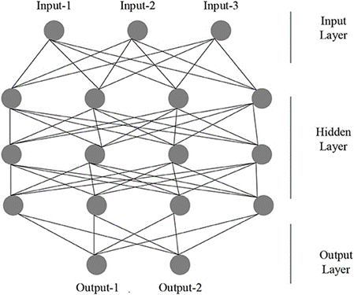
Figure: Structure of ANN (Artificial Neural Networks)
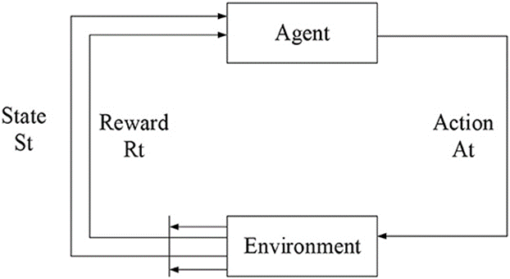
Figure: The schematic diagram of the reinforcement learning model.
In this system, a neural network is used to perceive the environment and extract relevant features. This information is then used to map the current state of the environment to a set of possible actions. The hierarchical reinforcement learning component of the system then determines the best action to take based on this mapping.
The beauty of this approach is that it reduces the reliance on the environment. Traditional path planning methods often struggle in complex environments because they rely heavily on pre-existing knowledge of the environment. However, the neural network and HRL-based system can quickly adapt to changes in the environment, making it much more flexible and robust.
Moreover, this system has been compared with other algorithms in path planning and has shown promising results. For example, it has been found to have a shorter path planning time and a reduced number of path steps compared to other methods. This makes it a highly efficient system for path planning in mobile robots.
The combination of neural networks and Hierarchical Reinforcement Learning presents a powerful tool for path planning in mobile robots. It offers a flexible and efficient solution that can adapt to complex environments, making it a significant step forward in the field of robotics. As an undergraduate student interested in robotics, understanding and exploring such techniques could open up exciting opportunities for research and innovation.
Some algorithms are used for path planning:
Q-Learning Algorithm: In the context of path planning, the Q-Learning algorithm is used to guide the robot's actions based on the rewards it receives from the environment. The algorithm maintains a table of Q-values for each state-action pair. The robot interacts with the environment and updates the Q-values based on the rewards it receives. The Q-value of a state-action pair represents the expected future reward for taking a particular action in a given state. The robot uses these Q-values to select the optimal action in each state, thus planning its path from its current position to the target position.
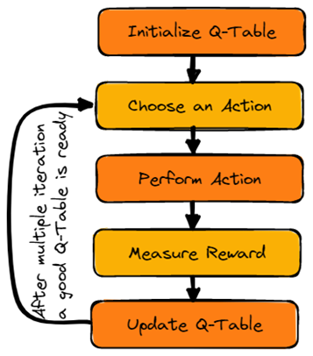
Figure: Source
DQN (Deep Q-Learning Network) Algorithm: The DQN algorithm extends the Q-Learning algorithm by using a neural network to approximate the Q-value function. This allows the algorithm to handle environments with a large number of states that would be impractical to handle with a traditional Q-Learning algorithm. In the context of path planning, the robot uses the DQN algorithm to select the optimal action in each state based on the Q-values predicted by the neural network. The neural network is trained to predict Q-values that maximize the expected future reward, thus guiding the robot to plan an optimal path to the target position.
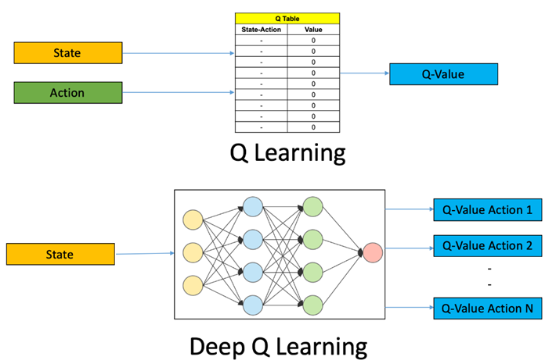
Figure: Source
PDQN (Potential DQN) Algorithm: The PDQN algorithm enhances the DQN algorithm by incorporating the concept of a potential field. In path planning, a potential field is a type of map that assigns a potential value to each point in the environment. The robot is attracted to points with low potential values and repelled by points with high potential values (such as obstacles). The PDQN algorithm uses the potential field to guide the robot's actions, in addition to the Q-values predicted by the neural network. This helps to accelerate the path planning process by guiding the robot towards the target position more directly.
A3C (Actor-Critic) Algorithm: The A3C algorithm is a type of reinforcement learning algorithm that uses two neural networks: an actor network that selects actions, and a critic network that evaluates the actions selected by the actor. In the context of path planning, the actor network guides the robot's actions, while the critic network provides feedback that is used to train the actor network. This allows the robot to learn an optimal policy for selecting actions that lead to the target position.
DDPG (Deep Deterministic Policy Gradient) Algorithm: The DDPG algorithm is a type of reinforcement learning algorithm that combines the concepts of DQN and A3C. It uses a neural network to approximate the Q-value function (like DQN) and another neural network to select actions (like A3C). In the context of path planning, the DDPG algorithm guides the robot's actions based on the Q-values and the policy predicted by the neural networks. This allows the robot to learn an optimal policy for path planning in a continuous action space.
DDQN (Double DQN) Algorithm: The DDQN algorithm is an enhancement of the DQN algorithm that reduces the overestimation of Q-values. In the context of path planning, the DDQN algorithm guides the robot's actions based on the Q-values predicted by two separate neural networks: one for selecting actions and another for estimating Q-values. This helps to improve the stability and performance of the path planning process.

